**Reception Curriculum Overview –**

**Spring**

Willow, Silver Birch and Hazel Class

Autumn Term 1

**This overview is intended to give you a flavour of what we will be learning this half term.**

[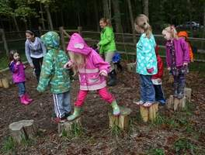](http://archive.cincinnati.com/apps/pbcs.dll/gallery?Site=AB&Date=20130926&Category=NEWS&ArtNo=309260113&Ref=PH)

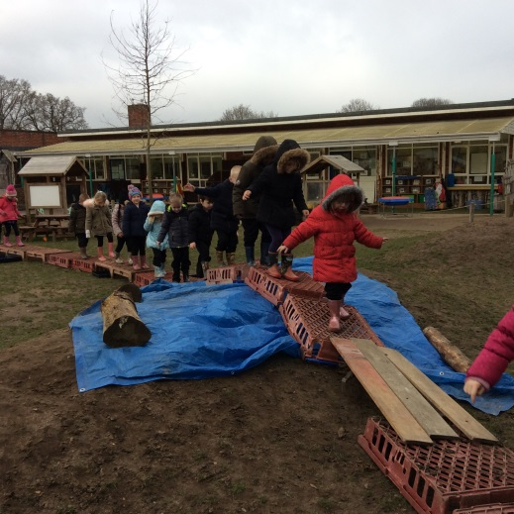

**Communication and Language**

* We support children to follow simple instructions
* We play games daily to support children’s listening and attention skills.
* Children will gain confidence in speaking and answering questions about themselves.
* We practise retelling a story daily that we have learnt in Talk for Writing. This term’s story is The Three Billy Goats Gruff.

**Physical development**

* We will use a variety of resources to strengthen the muscles in our fingers, such as threading and cutting with scissors. We are working on holding pencils using the correct finger grip.
* The children are encouraged to be active by exploring the outdoor area. We support them to take sensible risks in their play.
* We are taking part in a series of gymnastics sessions at the UEA.
* We will continue to have healthy snacks and lunches, run a daily mile and talk about keeping our bodies healthy.

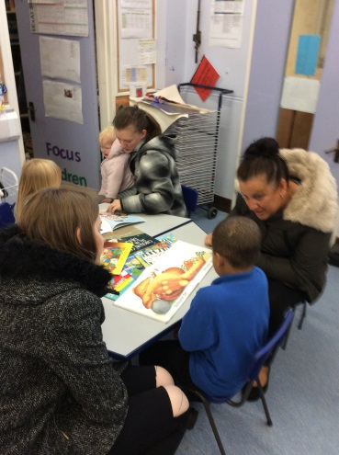

We would love to hear about what your child does at home. Please share your achievements or any ‘good learning’ you see at home.

[](http://archive.cincinnati.com/apps/pbcs.dll/gallery?Site=AB&Date=20130926&Category=NEWS&ArtNo=309260113&Ref=PH)

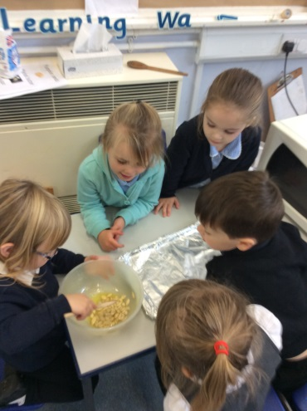

[](http://archive.cincinnati.com/apps/pbcs.dll/gallery?Site=AB&Date=20130926&Category=NEWS&ArtNo=309260113&Ref=PH)

[](http://archive.cincinnati.com/apps/pbcs.dll/gallery?Site=AB&Date=20130926&Category=NEWS&ArtNo=309260113&Ref=PH)

We love spending time outdoors and getting messy. Your child needs a spare clothes bag and a named pair of wellie boots in school at all times.

[](http://archive.cincinnati.com/apps/pbcs.dll/gallery?Site=AB&Date=20130926&Category=NEWS&ArtNo=309260113&Ref=PH)

[](http://archive.cincinnati.com/apps/pbcs.dll/gallery?Site=AB&Date=20130926&Category=NEWS&ArtNo=309260113&Ref=PH)

[](http://archive.cincinnati.com/apps/pbcs.dll/gallery?Site=AB&Date=20130926&Category=NEWS&ArtNo=309260113&Ref=PH)

**Personal, Social and Emotional development**

* We encourage children to be responsible learners and access resources independently.
* We help children to talk about their feelings, and share their opinions.
* Children are supported in forming good relationships with their peers and teachers. Children are taught how to work as part of a team and take turns in social situations.

[](http://archive.cincinnati.com/apps/pbcs.dll/gallery?Site=AB&Date=20130926&Category=NEWS&ArtNo=309260113&Ref=PH)

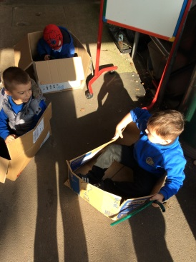

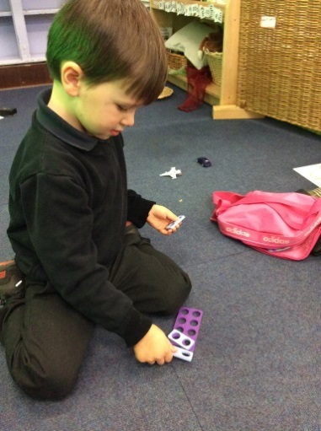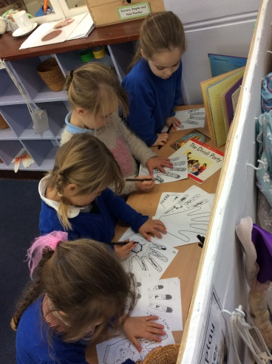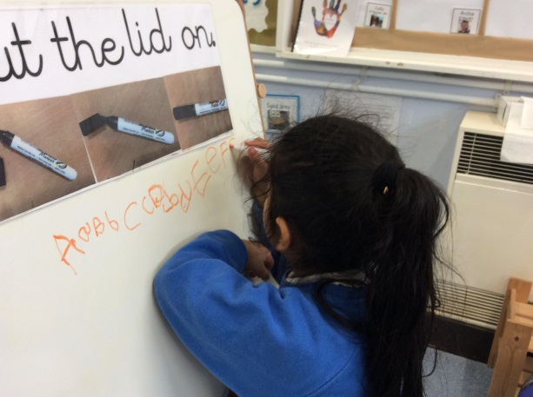

**Expressive Arts and Design**

* Children have access to a variety of media to create with, such as ribbons, buttons, boxes, paint, clay and salt dough, among many other things. They are encouraged to experiment with different materials and techniques.
* We listen to music and enjoy dancing and playing musical instruments.
* We encourage children to talk about and display their artwork and creations.

**Literacy**

* We will explore lots of fiction and non-fiction books linked to the child’s interests.
* We have daily Read Write Inc lessons to help children learn the sounds and skills they need to read and write.
* We encourage the children to write for a range of purposes, like books, letters and signs. We support them in writing using the sounds that they have learnt.
* Children are encouraged to tell stories and write them independently.

**Mathematics**

* Every day we count how many children are at school and recite numbers in order to 20. We support children in recognising numbers from 1-20.
* We use a variety of resources for counting. We will be learning to work out one more and one less from group of objects, and adding and taking away numbers.
* Children are encouraged to spot shapes in the environment, both 2D and 3D.

**Understanding of the World**

* We love to share news from home so please come and tell us any exciting news.
* We celebrate birthdays and other special events like Chinese New Year, RSPB birdwatch and Shrove Tuesday.
* Each class has their own gardening bed where we are learning to care for vegetables and watching them grow.

If you would like to volunteer in Reception, please talk to your child’s teacher.

Please continue to change your child’s book every day and update the reading record so we can celebrate the books you share together.