**Reception Curriculum Overview**

**Summer**

Willow, Silver Birch and Hazel Class

Autumn Term 1

**This overview is intended to give you a flavour of what we will be learning this half term.**

[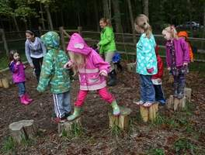](http://archive.cincinnati.com/apps/pbcs.dll/gallery?Site=AB&Date=20130926&Category=NEWS&ArtNo=309260113&Ref=PH)

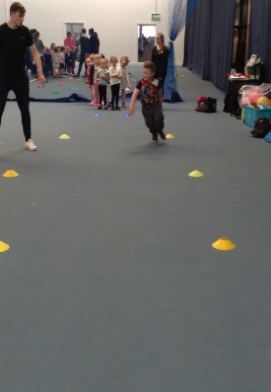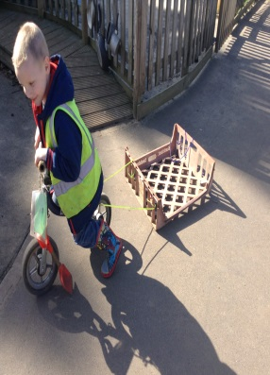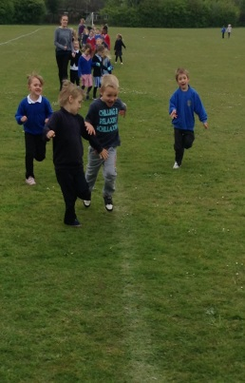

**Communication and Language**

* We will support children to follow two and three step instructions.
* We play games daily to support children’s listening, speaking and understanding.
* Children will gain confidence in asking questions and gaining answers about their learning.
* Children will be encouraged to talk in full sentences. We will model correctly spoken English.

**Physical development**

* We will take part in the ‘I can’t do it yet…’ day. We are working on physical development skills that need practise to get even better at.
* The children are encouraged to be active by exploring the outdoor area. We support them to take sensible risks in their play.
* We will be taking part in the ‘Race for Life’ at the UEA.
* We will eat healthy snacks and lunches, run a daily mile and talk about keeping our bodies healthy.

[](http://archive.cincinnati.com/apps/pbcs.dll/gallery?Site=AB&Date=20130926&Category=NEWS&ArtNo=309260113&Ref=PH)

We would love to hear about what your child does at home. Please share your achievements or any ‘good learning’ you see at home.

[](http://archive.cincinnati.com/apps/pbcs.dll/gallery?Site=AB&Date=20130926&Category=NEWS&ArtNo=309260113&Ref=PH)

[](http://archive.cincinnati.com/apps/pbcs.dll/gallery?Site=AB&Date=20130926&Category=NEWS&ArtNo=309260113&Ref=PH)

Learning outside is as important as learning inside. Sometimes this means we get messy. Your child needs a spare clothes bag and a named pair of wellie boots in school.

[](http://archive.cincinnati.com/apps/pbcs.dll/gallery?Site=AB&Date=20130926&Category=NEWS&ArtNo=309260113&Ref=PH)

[](http://archive.cincinnati.com/apps/pbcs.dll/gallery?Site=AB&Date=20130926&Category=NEWS&ArtNo=309260113&Ref=PH)

[](http://archive.cincinnati.com/apps/pbcs.dll/gallery?Site=AB&Date=20130926&Category=NEWS&ArtNo=309260113&Ref=PH)

**Personal, Social and Emotional development**

* We encourage children to be responsible learners and use equipment independently.
* We help children to talk about their feelings, care about others and talk about their opinions.
* We will be supporting children to be ready for Year 1. They will meet new teachers and visit the classes.

[](http://archive.cincinnati.com/apps/pbcs.dll/gallery?Site=AB&Date=20130926&Category=NEWS&ArtNo=309260113&Ref=PH)

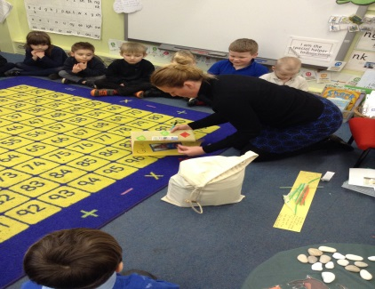

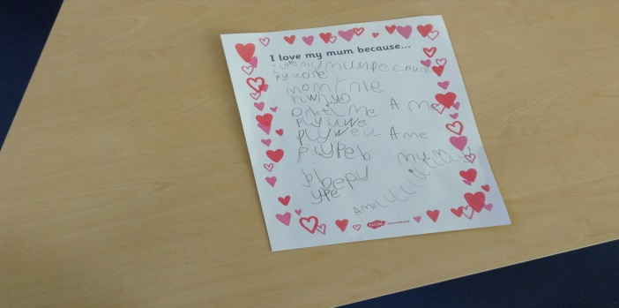

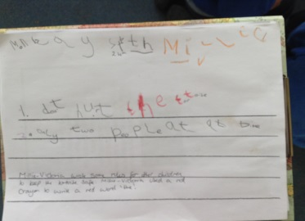

**Literacy**

* We will explore lots of fiction and non-fiction books linked to the child’s interests and Talk for Writing.
* Read Write Inc lessons help children learn sounds, blend words developing the skills they need to read and write.
* We encourage the children to write for a range of purposes for example labels, instructions, lists and ingredients.
* Children are encouraged to write stories through story scribing then retell them in class choosing characters for their story.

If you would like to volunteer in Reception, please talk to your child’s teacher.

Please continue to change your child’s book every day and update the reading record so we can celebrate the books you share together.

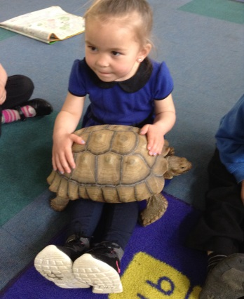

**Understanding of the World**

* We love to share news from home so please come and tell us any exciting or interesting news.
* We celebrate birthdays and other special events or achievements like ‘I can’t do it yet…’ day and ‘Race for Life’.
* Each class has their own incubator where we will be hatching off chicks, ducklings, quailing’s and watching them grow.
* We have gardening beds to grow vegetables.

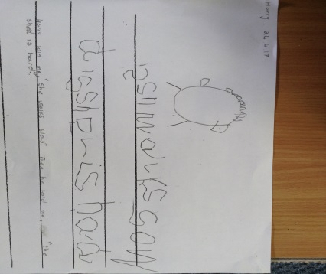

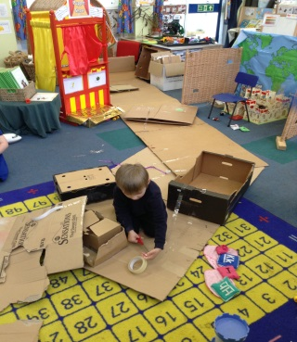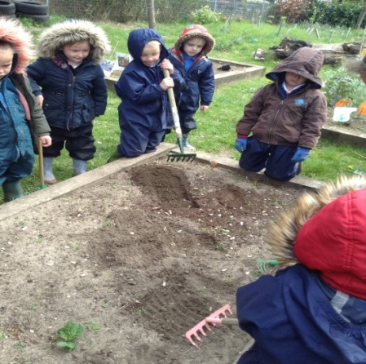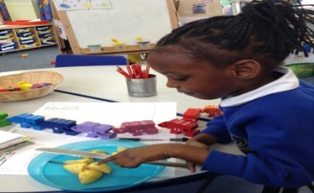

**Expressive Arts and Design**

* Children use a variety of media to create with, such as ribbons, buttons, boxes, paint, clay and salt dough. They are encouraged to experiment with powder paints to colour mix and create their own colours and shades.
* We listen to music and enjoy dancing and playing musical instruments.
* We encourage children to talk, display and write about their artwork and creations.

**Mathematics**

* Every day we count and recite numbers in order to 20. We support children in recognising numbers from 0-20 using items such as numicon.
* We will be revisiting time with songs for days of the week and months of the year, halving and doubling fruit, applying one more and one less. We will add and take away calculations in our class shops using real money 1p’s, 2p’s, 5p’s and 10p’s.
* Children are encouraged to describe the properties and spot shapes in the environment, both 2D and 3D.